**ESP8266 WEMOS D1 MINI MODULE**

* **Date of Creation or Update:**  
  25/12/2024
* **Prepared By:**

Muhammad Sabahat Akhter

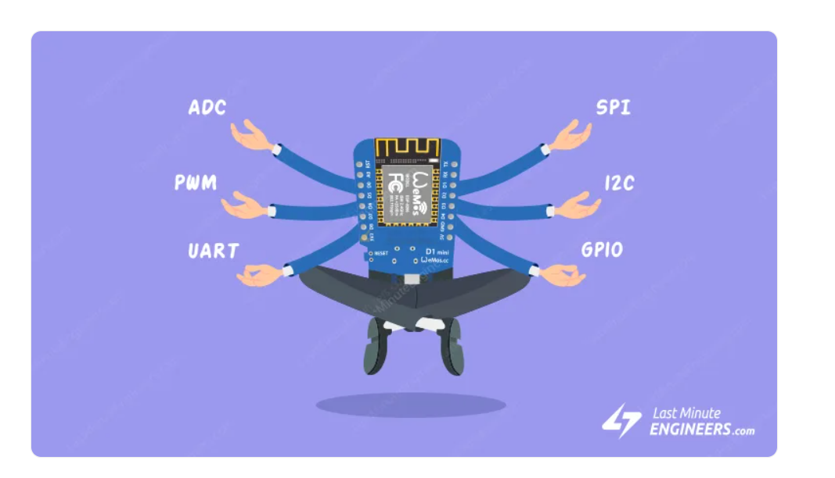

Table of Content

1. Description
2. PACKAGE INCLUDES
3. KEY FEATURES OF ESP8266 D1 MINI V2 ESP-12F WIFI MODULE
4. Digital and Analog I/O
5. Powering the Module
6. WeMos D1 Mini Pinout
7. GPIO Pins
8. ADC Pins
9. SPI Pins
10. I2C Pins
11. UART Pins
12. PWM Pins
13. Power Pins
14. Interrupt Pins
15. Control Pins

ESP8266 WEMOS D1 MINI

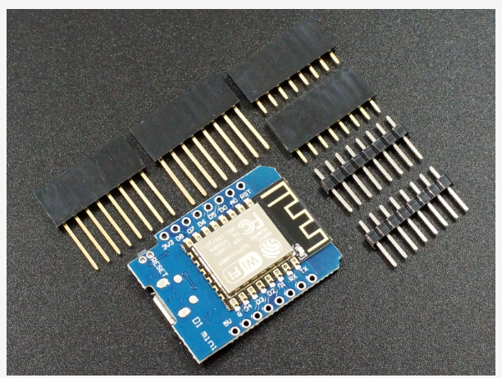

1. **Description**

The ESP8266 D1 Mini V2 ESP-12F WiFi Module is a powerful WiFi enabled processor in a compact package ideal for embedding into WiFi enabled projects.

1. **PACKAGE INCLUDES:**

* ESP8266 D1 Mini V2 ESP-12F WiFi Module
* Qty 2 – 1 x 8 Male Headers
* Qty 2 – 1 x 8 Female Headers
* Qty 2 – 1 x 8 Stackable Male/Female Headers

1. **KEY FEATURES OF ESP8266 D1 MINI V2 ESP-12F WIFI MODULE:**

* Microcontroller:      ESP-8266 32-bit
* Clock Speed:             80 / 160MHz
* USB Converter:        CH340
* USB Connector:       Micro USB
* Operating Voltage:  3.3V
* Flash Memory:         4 MB
* Digital I/O:                11
* Analog Inputs:          1
* Communications:     Serial, SPI.  I2C and 1-Wire via software libraries
* WiFi:                           Built-in 802.11 b/g/n
* Programming:          Compatible with Arduino IDE and NodeMCU

Besides adding WiFi capability, the main claim to fame for the ESP8266 processor over the AVR processor of the standard Arduino is that it has a larger 4 MB of Flash memory and runs at clock speeds of 80 MHz and can sometimes optionally be overclocked to 160 MHz and therefore has a very fast processing speed.  These can be used as a stand-alone MCU in place of something like an Arduino or it can be used as a peripheral in conjunction with another MCU just to provide WiFi capability.

The module has a typical ‘**Reset**‘ button which resets the processor.

The module ships with a selection of headers depending on intended usage.

1. **Digital and Analog I/O**

All of the Digital I/O support PWM and interrupts except D0.  In addition they can be configured to have pull-up or pull-down resistors.  Though there are 11 digital I/O pins, 2 are typically reserved for use as the TX/RX lines if serial communications are used which leaves 9 digital I/O for other uses.

The blue on-board LED is connected to pin D4 (GPIO2) and can be accessed using the LED_BUILTIN constant.

Per spec, the digital I/O is limited to 3.3V, but the mfr has made statements that the digital pins are in fact 5V tolerant and there are many installations using the module directly connected to the logic lines of 5V MCUs.

The analog input is limited to a single 10-bit ADC input which is probably the most significant limitation for some sensor type applications. That limitation can always be overcome by using an external Analog Mux module like our 16-channel 74HC4067 or our ADS1115 4-channel 16-bit ADC module below if more analog I/O is desired.

The analog input does need to be limited to a maximum voltage of 3.2V or less on the A0 pin.  The module has a built-in 100K/220K resistor voltage divider on this pin that reduces the amplitude to a maximum of 1V at the ESP8266 processor which is the max that it can handle.

1. **Powering the Module**

The module can be powered via the USB port or by using an external 5V power supply connected to the 5V pin.

The 3.3V pin provides 3.3V output when powering the module from USB or 5V.  This output can be used to power an attached module such as a sensor.

It is also possible to power the module directly from 3.3V by using the 3.3V pin as an input, but in that case the USB cable or external 5V cannot be connected or there will be a conflict on the 3.3V power line.  Typically it is best to stick with powering the module from 5V.

When it comes to ESP8266 boards, the WeMos D1 Mini stands out as a great choice for those just getting started with IoT. It’s small, well-supported, and ridiculously cheap, with prices as low as $3 USD per unit. This affordability has made it a favored option among both hobbyists and professionals alike.

In this article, we will look at the WeMos D1 Mini pinout in detail.

1. WeMos D1 Mini Pinout

The D1 Mini has 16 pins in total. The pinout is as follows:

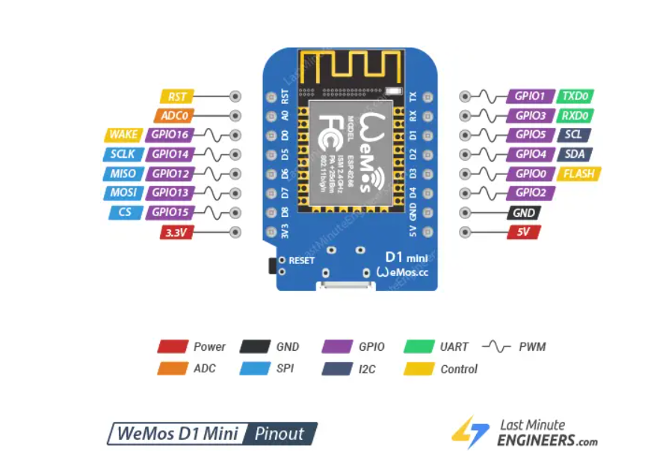

Let’s take a closer look at the WeMos D1 Mini pins and their functions one by one.

1. GPIO Pins

The D1 Mini has 11 GPIO pins that can be programmed to perform a variety of functions. Each GPIO can be configured with an internal pull-up or pull-down resistor, or it can be set to high impedance.

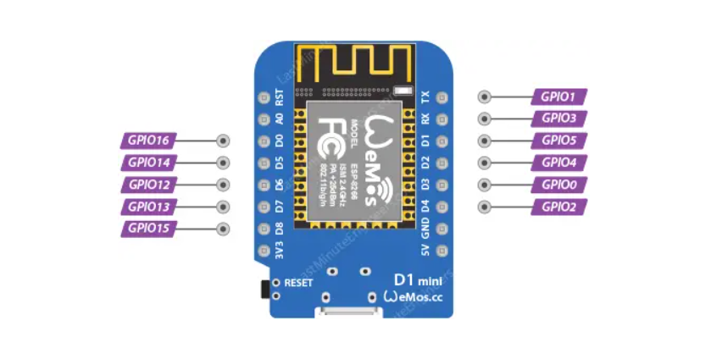

Keep in mind that all pins are 3.3V logic level; exceeding this voltage will cause damage to the board.

Which GPIOs are safe to use?

Although the D1 Mini has a lot of pins with various functions, some of them may not be suitable for your projects. The table below shows which pins are safe to use and which pins should be used with caution.

* – Your top priority pins. They are perfectly safe to use.
* – Pay close attention because their behavior, particularly during boot, can be unpredictable. Use them only when absolutely necessary
* – It is recommended that you avoid using these pins.

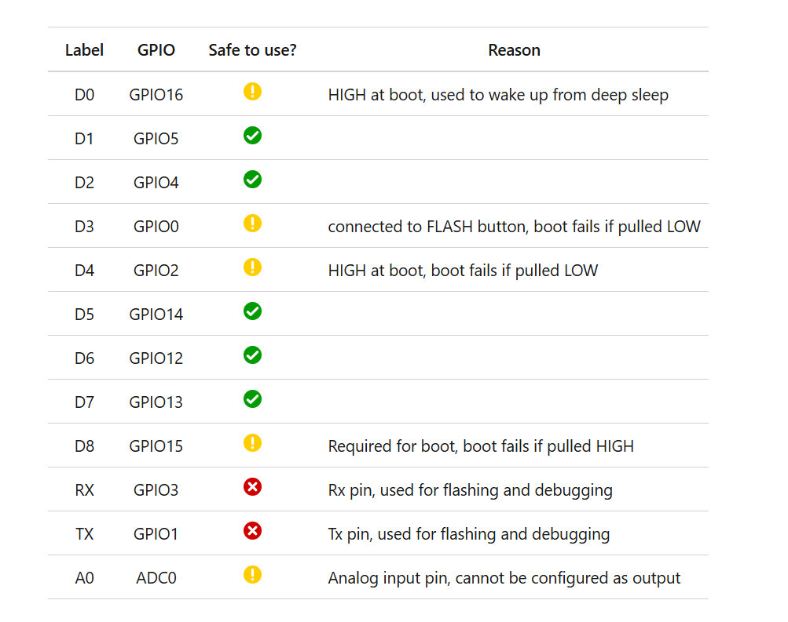

The image below shows which GPIO pins can be used safely.

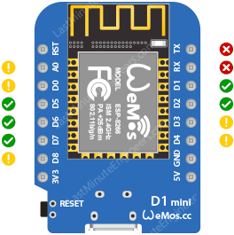

1. ADC Pins

The D1 Mini has a single analog input, A0. This analog input pin can measure voltages from 0 to 3.3V.

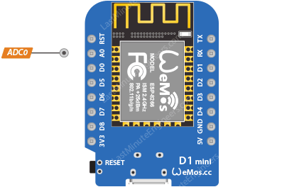

It’s connected to a built-in SAR ADC with a resolution of 10-bits, which means it can differentiate 1024 (2^10) different voltage levels. In other words, it can convert input voltages ranging from 0 to 3.3V (operating voltage) into integer values ranging from 0 to 1024. This results in a resolution of 3.3 volts / 1024 units, or 0.0032 volts (3.2 mV) per unit.

1. SPI Pins

The D1 Mini has one hardware SPI interface (HSPI). It supports the general-purpose SPI features listed below:

* Full-duplex SPI communication
* 4 timing modes of the SPI format transfer
* Clock frequency is 20 MHz at maximum
* Up to 64-Byte FIFO

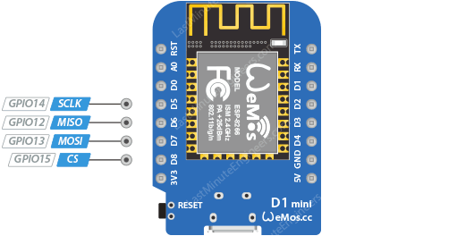

It’s worth noting that while there is only one SPI bus, software SPI (also known as bit-banging) can be implemented on any GPIO pins if additional SPI buses are required, but at the expense of speed and possibly increased CPU usage.

Ezoic

1. I2C Pins

The D1 Mini has a single I2C interface which is realized via software programming (‘bit-banging’), meaning any GPIO pin can be defined to act as SCL and SDA. It works quite well, and the ESP8266 is fast enough to match ‘Arduino level’ speed (clock frequency is 100 kHz at maximum).

By default, GPIO4 (SDA) and GPIO5 (SCL) are used for I2C communication and are the default I2C pins for many libraries and examples you will find.

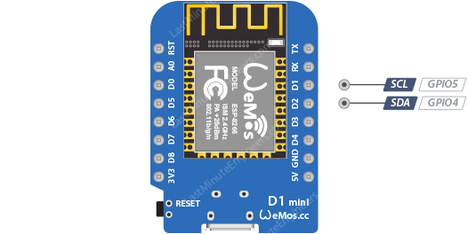

11. UART Pins

The D1 Mini has a single usable UART (Universal Asynchronous Receiver/Transmitter) interface, which is used for programming as well as general serial communication (e.g., sending or receiving data to and from a computer or a serial interface sensor).

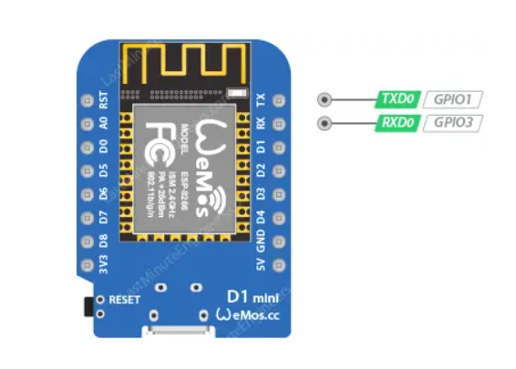

These pins are connected through to the CH340 USB-to-Serial converter so they should not be connected to or used unless you are absolutely certain you want to because you will also be getting USB traffic on these!

14. PWM Pins

Almost all digital pins (except D0) can produce a Pulse Width Modulation (PWM) signal. This is useful for controlling the speed of motors, dimming LEDs, and more.

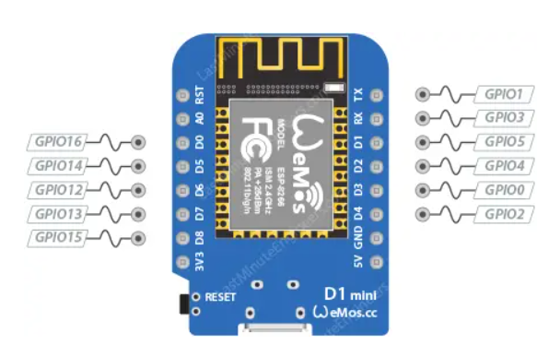

Note that the PWM signal has a 10-bit resolution, and the PWM frequency range is adjustable between 1000 μs and 10000 μs, i.e., between 100 Hz and 1 kHz.

15. Power Pins

The WeMos D1 Mini has several pins dedicated to power:

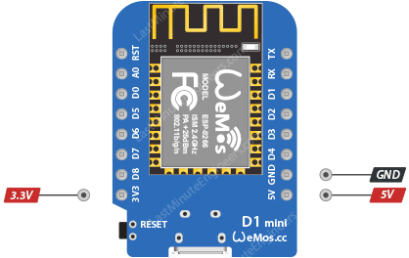

5V pin: When connected via USB, this pin outputs a 5V supply drawn directly from the USB port. It can also be used to power the board when using an external power source.

3V3 pin: This pin provides a 3.3V output which can be used to power external components. The power is drawn from the on-board voltage regulator and has a limited supply current; you can get up to 600mA from it.

GND: is the ground pin.

16. Interrupt Pins

All GPIOs (except GPIO16) can be configured to trigger an interrupt on a rising, falling, or a change of state. This is essential for event-driven tasks like responding to a button press or a sensor signal.

17. Control Pins

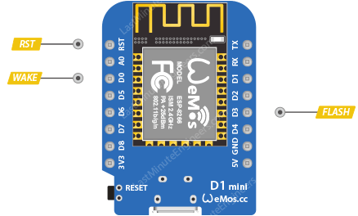

The RST pin is the reset pin. Pulling this pin low resets the microcontroller, which is the same as pressing the reset button on the board.

The FLASH pin is used by the D1 Mini to determine when to boot into the bootloader. By pulling this pin low during power-up, you can put the D1 Mini into flashing mode, which is necessary for programming the board with new firmware.

The WAKE pin is used to wake the D1 Mini from deep sleep.